**Phys 11A - Eiteneer**

**Lab: Energy Conservation**

**Online version**

**Note: this lab was originally written by** Trish Loeblein, and modified by Professor Eiteneer

**Name: _________________________________________________________________________________**

## PURPOSE

The purpose of this lab is to experiment with different kinds of systems to see how/when energy conservation is applied. Practice using CoE to calculate the value of speed and energy from information about a different position.

### Part I: Skate Park

1. Go to <https://phet.colorado.edu/en/simulation/legacy/energy-skate-park>, and download the simulation.
2. Play with the features shown to the right and the purple dot data to understand how to adjust them and what the data means. Figure out how to measure position **exactly**. Then, once you are comfortable with different parts, you can restart the simulation to perform the experiment. Note that changing the Skater only changes the mass.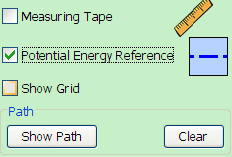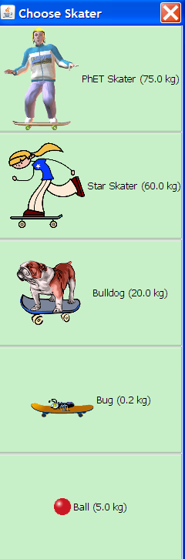
3. Explain what changes and how when you move the PE reference line.
4. Reset the simulation. Change the skater and explain if/what is different. Do any values change?
5. Create a “custom track” that includes minimum of six different points as shown. The shape of your graph will vary, but make sure to include some “hills” and “valleys”. You can also use one of the pre-built tracks (see “tracks”) and modify it. Choose one of the Skaters and record the mass: 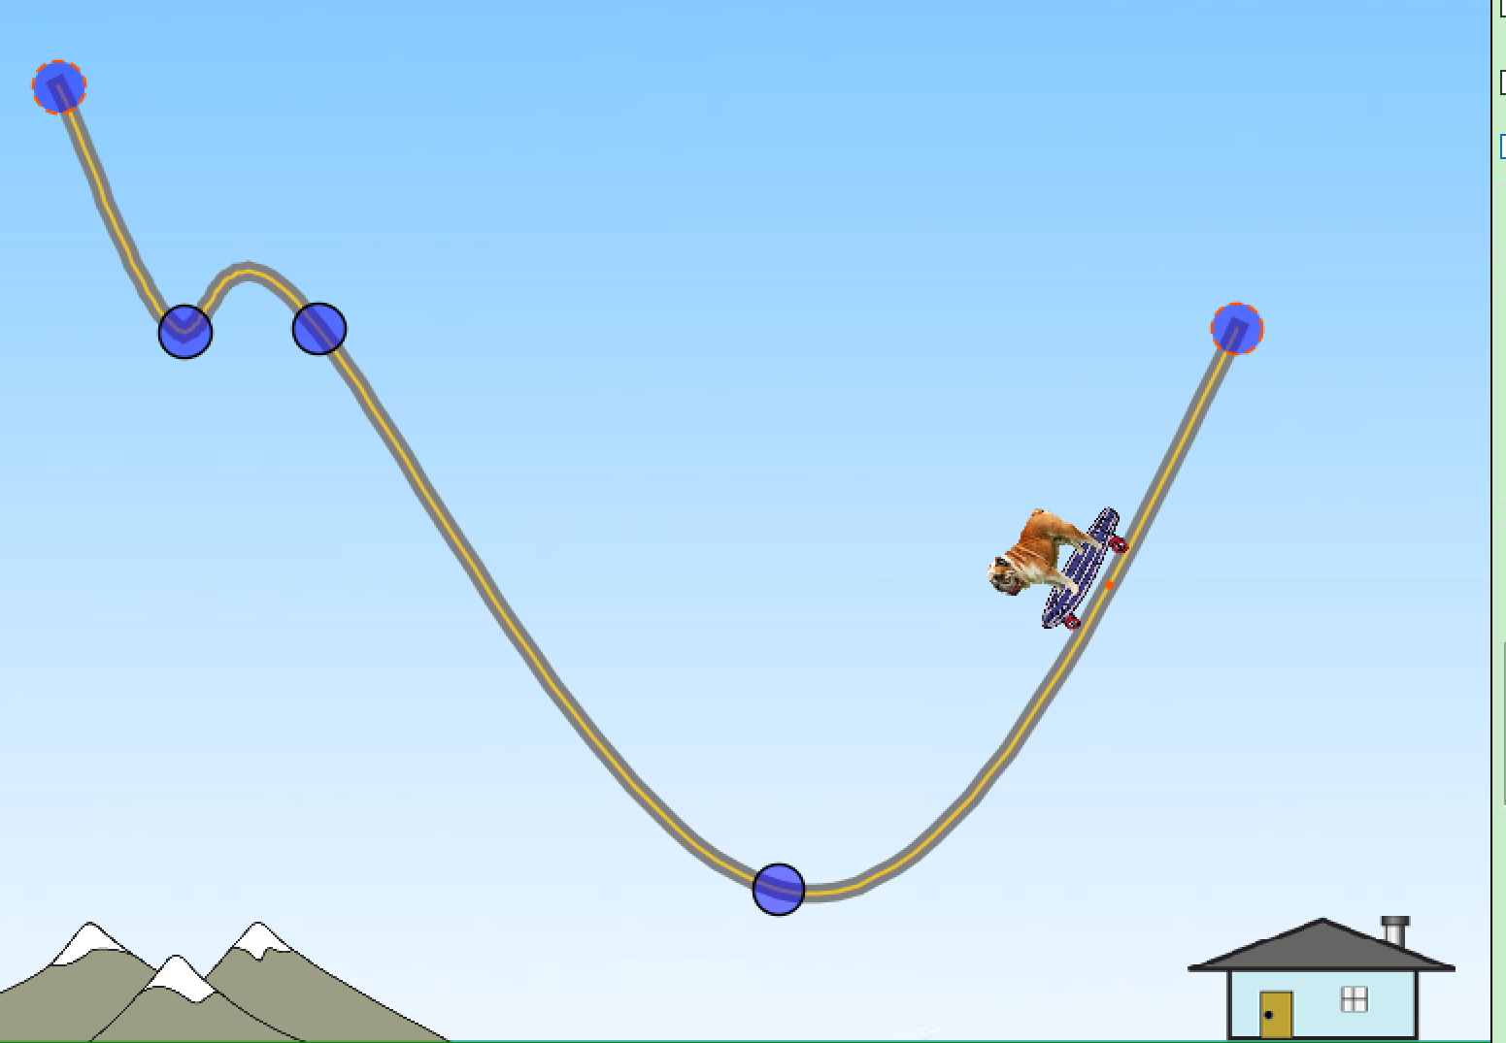

m = _________________ [kg]

1. Put the Skater on a track, Show Path and display the purple dot data. How could you predict the values for another place on the track? In your answer, describe what you would have to measure. Include the screen capture of your track. Label your points (1, 2, …)
2. Show **how** you would perform the calculations for each of the following values: K, U, Etotal, speed.
3. Move your Skater to the highest point on the track, and give the Skater initial speed.
4. Let the Skate, and fill out the following table. Use the measuring tape included in the simulation to measure height **exactly**. Note: this may take a bit of practice – remember, you can always pause the simulation to make the measurement!

|  |  |  |  |  |  |
| --- | --- | --- | --- | --- | --- |
| **Point** | **Height [m]** | **U [J]** | **Speed [m/s]** | **K [J]** | **Etot [J]** |
| **1** |  |  |  |  |  |
| **2** |  |  |  |  |  |
| **3** |  |  |  |  |  |
| **4** |  |  |  |  |  |
| **5** |  |  |  |  |  |
| **6** |  |  |  |  |  |

1. Make a graph of energies: energy on the vertical axis, height on the horizontal axis. On the same graph, plot K, U, Etot. You can use Excel to graph, or do it by hand. If using Excel, use “scatterplot” option, **do not** use “connected dots”. Make sure to label the graph, and the axes (with units). Include a screenshot of your graph, or attach it to this lab report.
2. Based on your graph, describe the trends/shapes of the three curves. Hint: you can also enable “graphs” in the simulation to help you answer this question.
3. Is there a place on your “custom track” where the Skater goes off track? **Explain why or why not**.
4. Describe what you think will change in your calculations if you move the Skater to Jupiter.
5. Describe what you would have to measure.
6. Show an example of your proposed calculations for each value: K, U, Etotal,, speed.
7. Test your ideas and include a screen capture with the purple dot data shown to support your calculation.
8. How do your calculations change if you take the Skater to the moon? Test your ideas and correct if necessary.

### Part II: Mass-Spring system

1. Go to <https://phet.colorado.edu/en/simulation/masses-and-springs>, and run or download the simulation. When you open the simulation, click on the Lab option.
2. Play with different features of the lab to understand how to adjust them and what the data means. Specifically, figure out how to change mass, spring constant, and damping. Figure out how to measure position **exactly** (hint: use a ruler included in the simulation!). Then, once you are comfortable with different parts, you can restart the simulation to perform the experiment.
3. Show **how** you would perform the calculations for each of the following values: K, U, Etotal, speed.
4. Pick a value of mass, and make an assumption about the value of a spring constant and record both. Set the damping to zero for now.

m = _________________ [kg] k = _________________ []

1. Set the system in motion, and fill out the following table. You may include more data points if you’d like. Use the ruler included in the simulation to measure displacement from equilibrium. Note: this may take a bit of practice – remember, you can always pause the simulation to make the measurement!

|  |  |  |  |  |  |
| --- | --- | --- | --- | --- | --- |
| **Point** | **Displacement [m]** | **U [J]** | **Speed [m/s]** | **K [J]** | **Etot [J]** |
| **1** |  |  |  |  |  |
| **2** |  |  |  |  |  |
| **3** |  |  |  |  |  |
| **4** |  |  |  |  |  |
| **5** |  |  |  |  |  |

1. Make a graph of energies: energy on the vertical axis, displacement on the horizontal axis. On the same graph, plot K, U, Etot. You can use Excel to graph, or do it by hand. If using Excel, use “scatterplot” option, **do not** use “connected dots”. Make sure to label the graph, and the axes (with units). Include a screenshot of your graph, or attach it to this lab report.
2. Based on your graph, describe the trends/shapes of the three curves. Hint: you can also use “graphs” in the simulation to help you answer this question.
3. Now pick some non-zero value of damping and describe qualitatively what happens. Try to include as much details as possible.